
20’s Plenty is a non-party political Campaign that advocates a 20 mph limit in residential areas.

The ADVANTAGES of 20mph limits are:
SAFER STREETS FOR ALL, PARTICULARLY CHILDREN AND THE ELDERLY
- Less risk of serious injury;
- less intimidation from motor vehicles for all road users and especially those walking and cycling.
ENVIRONMENTAL IMPROVEMENTS
- improved air quality, quieter and more friendly roads
- reinforcing healthy lifestyles by encouraging walking, cycling and active travel
BETTER COMMUNITY LIFE AND A POSITIVE IMAGE OF RESIDENTIAL AREAS
- 20mph enables lifestyle changes, renewed community life, sociability and the positive atmosphere
“There are 20% fewer casualties in 20mph areas.”
“Slower speed limits help people to increase the amount they walk and cycle and don’t affect journey times significantly”.

“20mph limits emphasise quality of life, helping to create places for walking, cycling, talking..”

For Further Information contact: 20’s Plenty for Us:
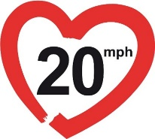
www.20splenty.org info@20splenty.org
07572 120439 @20splentyforus

